 

**INSTITUTE FOR ADVANCED COMPUTING AND  SOFTWARE DEVELOPMENT AKURDI, PUNE**

Project On

**“Urban Estate”- An Online Property Dealing Site**

PG-DAC SEPT 2022

**Submitted By:**

**Group No: 06**

**Roll No. Name:**

1. **229007 Ajinkya Rokade**
2. **229175 Nikhil Dhage**

#### Mrs. Sonali Mogal Mr. Rohit Puranik

**Project Guide Course Co-Coordinator**



**CERTIFICATE**

This is to certify that the project work under the title ‘An Online Property Dealing Site’ is done by **Ajinkya Rajendra Rokade** and **Nikhil Naresh Dhage** in partial fulfilment of the requirement for award of Diploma in Advanced Computing Course.

#### Mrs. Sonali Mogal Mr. Rohit Puranik

**Project Guide Course Co-Coordinator**

Date: 11/03/2023

**Acknowledgement**

We are grateful to our respectable teacher, **Mr. Rohit Puranik** (Center Coordinator, IACSD, Pune), **Mrs. Sonali Moghal** (Project Guide), whose insightful leadership and knowledge benefited us to complete this project successfully. Thank you so much for your continuous support and presence whenever needed*.*

We are deeply indebted and grateful to them for their guidance, encouragement and deep concern for our project. Without their critical evaluation and suggestions at every stage of the project, this project could never have reached its present form.

We would like to thank him for giving us valuable suggestions and ideas, as well as the college that provided all of the resources needed in order for it to be successful.

Last but not the least we thank the entire faculty and the staff members of Institute for Advanced Computing & Software Development, Pune for their support.

**Ajinkya Rokade(229007)**

**Nikhil Dhage(229175)**

# **Index**

|  |  |
| --- | --- |
| Sr. No | Title |
| 1 | Introduction |
| 2 | Business Requirements Overview |
| 3 | System Features and Requirements |
| 3.1 Functional Requirements |
| 3.2 Non- Functional Requirements |
| 4 | Design |
| 4.1 Database Design |
| 5 | UML Diagram |
| 6 | Screen Shots |
| 7 | Software And Hardware Requirement |
| 8 | Future scope |
| 9 | Conclusion |
| 10 | References |

# **Introduction**

Online property dealing website provides common platform for certified sellers and customers to rent, sell, buy properties including flats, bungalow, plots, commercial offices, shops and student PG etc.

It will also bridge the gap between customers and certified property sellers, where sellers will be able to advertise their properties on this platform and customers will be able to search for properties, view property details, book appointment, contact property owners or agents, book and reserve properties, review sellers and properties and make payments through the platform both with comfort of their home and will also enable customers to avail property related services like packing and moving, Electrical and Plumbing maintenance, pest control, Cleaning etc.

This system will provide a platform to certified home line property sellers and buyers which will keep record of legal properties available for sale or on rent with their rates and make this available to customers at one place where customers can pay rent.

The motive of developing this application is to design a feature rich search engine which can make the search of commercial land/properties an easy task.

This web application’s frontend is developed with React JS, backend with Spring boot and for data persistence MySQL RDBMS is used.

* 1. **Purpose of the project**

This is initiative to create an online platform for customers to rent/buy properties at best and competitive price and will act as a broker between customer and seller with zero brokerage fees. This platform will also serve the customers with relevant services with reasonable rates.

* 1. **Scope**

The scope of this project would include designing and developing a digital platform that allows certified sellers to advertise their properties online and allows customers to visit the properties online with ocean of data regarding the property. This platform will allow users to search for properties using various filters such as location, price, property type, and amenities. Users will be able to view detailed information about properties, including images, floor plans, and amenities. They will also be able to contact property owners or agents and make bookings or reservations. A payment gateway will be integrated to facilitate transactions

# **Business Requirements Overview**

* It is the public web application.
* There are mainly three types roles first admin, second is seller and third one is customer.
* The Users will search for the properties and will contact seller, schedule appointment and book property.
* The administrator is maintaining the user profiles, sellers and properties listed.
* The user will have to register and login first in order to view the property.
* This platform could be maintained by Administrator.

# **System Features and Requirements**

* 1. **Functional Requirements**

**User Module -**

* + **User registration and login**

Users will be able to register and create accounts on the site. They will also be able to log in to their accounts to access additional features such as property booking and reservation.

* + **Property searching**

Users will be able to search for properties using various filters such as location, price, property type, and amenities. They will be able to view detailed information about properties, including images, floor plans, and amenities.

* + **Contact property owner or agent**

Users will be able to contact property owners or agents through the platform. They will be able to send messages, make phone calls, or schedule appointments through the site.

* + **Property booking and reservation**

Users will be able to book and reserve properties through the platform. They will be able to select dates and times for their booking or reservation.

* + **Services booking and scheduling**

Users will be able to book relevant services like Moving and packing, pest control and cleaning, Electrical and Plumbing maintenance and will also be able to schedule the booking as per their requirement.

* + **Payment gateway integration**

A payment gateway will be integrated into the platform to facilitate transactions for paying rents. Users will be able to make payments for property bookings or reservations through the site.

* + **Reviews**

Users will be able to post reviews about seller and property after visit to the property and also will be able to rate the property.

**Seller Module**

* + **Seller registration and login**

Seller will be able to register and create account on this platform with required documents for verification, Admin panel will verify the documents and information regarding seller and upon verification seller will be able to list the properties.

* + **Property Listing**

Upon verification, seller will be able to list the properties with legal documents such as RERA registration, NOC, Municipal registration documents etc. Admin panel will verify the documents and property will be listed to the platform available for users.

* + **Property De-listing**

After booking or renting, seller will be able to de-list the property from the platform.

* + **Update property**

Seller will be able to update the property based on the current status of property.

**Admin Module:**

* + **Admin panel for managing properties and users**

An admin panel will be provided for managing properties sellers and users. Admins will be able to add, edit, and delete properties and users. They will also be able to view and manage bookings and reservations.

* + **Admin data management**

Admins will be able to access all the statistical data related to properties, sellers and users in the form of graphs, pie charts and tables.

* 1. **Non-Functional Requirements**

1. **Security**

The system’s back-end servers shall only be accessible to authenticated administrators. Sensitive data will be encrypted before being sent over insecure connections like the internet.

1. **Availability**

The system should be available at all times, meaning the user can access it using a web browser, only restricted by the downtime of the server on which the system runs. In case of an of a hardware failure or database corruption, a replacement page will be shown. Also, in case of a hardware failure or database corruption, backups of the database should be retrieved from the server and saved by the administrator. Then the service will be restarted. It means 24 X 7 availability.

1. **Reliability**

The reliability of the overall program depends on the reliability of the separate components. The main pillar of the reliability of the system is the backup of the database which is continuously maintained and updated to reflect the most recent changes. Thus, the overall stability of the system depends on the stability of container and its underlying operating system.

1. **Maintainability**

A commercial database is used for maintaining the database and the application server takes care of the site. In case of a failure, a re-initialization of the program will be done. Also, the software design is being done with modularity in mind so that maintainability can be done efficiently.

1. **Accessibility**

The system will be a web-based application it is going to be accessible on the web browser.

1. **Back up**

We will take a backup in our system database. In order to enable the administrator and the user to access the data from our system.

1. **Performance**

The product shall be based on web and has to be run from a web server. The product shall take initial load time depending on internet connection strength which also depends on the media from which the product is run. The performance shall depend upon hardware components of the client/customer.

1. **Supportability**

The source code developed for this system shall be maintained in configuration management tool.

# **DATABASE DESIGN**

1. 1. **Database Design**

Databases are the storehouses of data used in the software systems. The data is stored in tables  inside the database. Several tables are created for the manipulation of the data for the system. The following table structures depict the database design.

1. **Admin**

|  |  |  |  |  |  |
| --- | --- | --- | --- | --- | --- |
| **Field** | **Type** | **Null** | **Key** | **Default** | **Extra** |
| id | bigint | NO | PRI | NULL | auto_increment |
| email | varchar(50) | YES | UNI | NULL |  |
| name | varchar(50) | YES |  | NULL |  |
| password | varchar(50) | NO |  | NULL |  |

1. **Appointment**

|  |  |  |  |  |  |
| --- | --- | --- | --- | --- | --- |
| **Field** | **Type** | **Null** | **Key** | **Default** | **Extra** |
| id | bigint | NO | PRI | NULL | auto_increment |
| appointment_date | date | YES |  | NULL |  |
| status | varchar(30) | YES |  | NULL |  |
| buyer_id | bigint | YES | MUL | NULL |  |
| property_id | bigint | YES | MUL | NULL |  |

1. **Buyer**

|  |  |  |  |  |  |
| --- | --- | --- | --- | --- | --- |
| **Field** | **Type** | **Null** | **Key** | **Default** | **Extra** |
| id | bigint | NO | PRI |  | auto_increment |
| city | varchar(50) | NO |  |  |  |
| line1 | varchar(60) | NO |  |  |  |
| line2 | varchar(60) | NO |  |  |  |
| pincode | int | NO |  |  |  |
| state | varchar(60) | NO |  |  |  |
| email | varchar(50) | NO | UNI |  |  |
| first_name | varchar(30) | NO |  |  |  |
| last_name | varchar(30) | NO |  |  |  |
| mob_no | bigint | NO |  |  |  |
| password | varchar(50) | NO |  |  |  |

1. **Feedbacks**

|  |  |  |  |  |  |
| --- | --- | --- | --- | --- | --- |
| **Field** | **Type** | **Null** | **Key** | **Default** | **Extra** |
| id | bigint | NO | PRI |  | auto_increment |
| comments | varchar(200) | YES |  |  |  |
| rating | int | NO |  |  |  |
| propert_id | bigint | YES | MUL |  |  |

1. **Image**

|  |  |  |  |  |  |
| --- | --- | --- | --- | --- | --- |
| **Field** | **Type** | **Null** | **Key** | **Default** | **Extra** |
| id | bigint | NO | PRI |  | auto_increment |
| image_url | varchar(100) | YES |  |  |  |
| property_id | bigint | YES | MUL |  |  |

1. **Owner**

|  |  |  |  |  |  |
| --- | --- | --- | --- | --- | --- |
| **Field** | **Type** | **Null** | **Key** | **Default** | **Extra** |
| id | bigint | NO | PRI |  | auto_increment |
| city | varchar(50) | NO |  |  |  |
| line1 | varchar(60) | NO |  |  |  |
| line2 | varchar(60) | NO |  |  |  |
| pincode | int | NO |  |  |  |
| state | varchar(60) | NO |  |  |  |
| mobile_no | bigint | YES |  |  |  |
| email | varchar(50) | YES | UNI |  |  |
| first_name | varchar(50) | YES |  |  |  |
| last_name | varchar(50) | YES |  |  |  |
| password | varchar(50) | YES |  |  |  |

1. **Properties**

|  |  |  |  |  |  |
| --- | --- | --- | --- | --- | --- |
| **Field** | **Type** | **Null** | **Key** | **Default** | **Extra** |
| id | bigint | NO | PRI |  | auto_increment |
| city | varchar(50) | NO |  |  |  |
| line1 | varchar(60) | NO |  |  |  |
| line2 | varchar(60) | NO |  |  |  |
| pincode | int | NO |  |  |  |
| state | varchar(60) | NO |  |  |  |
| amenities | varchar(300) | YES |  |  |  |
| total_area | double | NO |  |  |  |
| no_of_bedrooms | int | NO |  |  |  |
| description | varchar(50) | YES |  |  |  |
| name | varchar(50) | NO |  |  |  |
| price | double | NO |  |  |  |
| prop_type | varchar(50) | NO |  |  |  |
| property_for | int | NO |  |  |  |
| registration_id | int | NO |  |  |  |
| status | varchar(50) | YES |  |  |  |
| buyer_id | bigint | YES | MUL |  |  |
| owner_id | bigint | YES | MUL |  |  |
|  |  |  |  |  |  |

1. **wishlist**

|  |  |  |  |  |  |
| --- | --- | --- | --- | --- | --- |
| **Field** | **Type** | **Null** | **Key** | **Default** | **Extra** |
| id | bigint | NO | PRI |  | auto_increment |
| buyer_id | bigint | YES | MUL |  |  |

1. **property_wishlist**

|  |  |  |  |  |  |
| --- | --- | --- | --- | --- | --- |
| **Field** | **Type** | **Null** | **Key** | **Default** | **Extra** |
| wishlist_id | bigint | NO | MUL |  |  |
| property_id | bigint | NO | MUL |  |  |

1. **Service**

|  |  |  |  |  |  |
| --- | --- | --- | --- | --- | --- |
| **Field** | **Type** | **Null** | **Key** | **Default** | **Extra** |
| id | bigint | NO | PRI |  | auto_increment |
| description | varchar(200) | YES |  |  |  |
| service_name | varchar(50) | NO |  |  |  |
| rate | double | NO |  |  |  |
| vendor_name | varchar(50) | NO |  |  |  |

1. **service_buyer**

|  |  |  |  |  |  |
| --- | --- | --- | --- | --- | --- |
| **Field** | **Type** | **Null** | **Key** | **Default** | **Extra** |
| id | bigint | NO | PRI |  | auto_increment |
| start_date | date | YES |  |  |  |
| status | varchar(30) | YES |  |  |  |
| buyer_id | bigint | YES | MUL |  |  |
| property_id | bigint | YES | MUL |  |  |
| service_id | bigint | YES | MUL |  |  |

1. **Transaction**

|  |  |  |  |  |  |
| --- | --- | --- | --- | --- | --- |
| **Field** | **Type** | **Null** | **Key** | **Default** | **Extra** |
| id | bigint | NO | PRI |  | auto_increment |
| transaction_amount | double | NO |  |  |  |
| transaction_date | date | YES |  |  |  |
| buyer_id | bigint | YES | MUL |  |  |
| property_id | bigint | YES | MUL |  |  |

# **UML Diagrams**

**Manual ER Diagram**

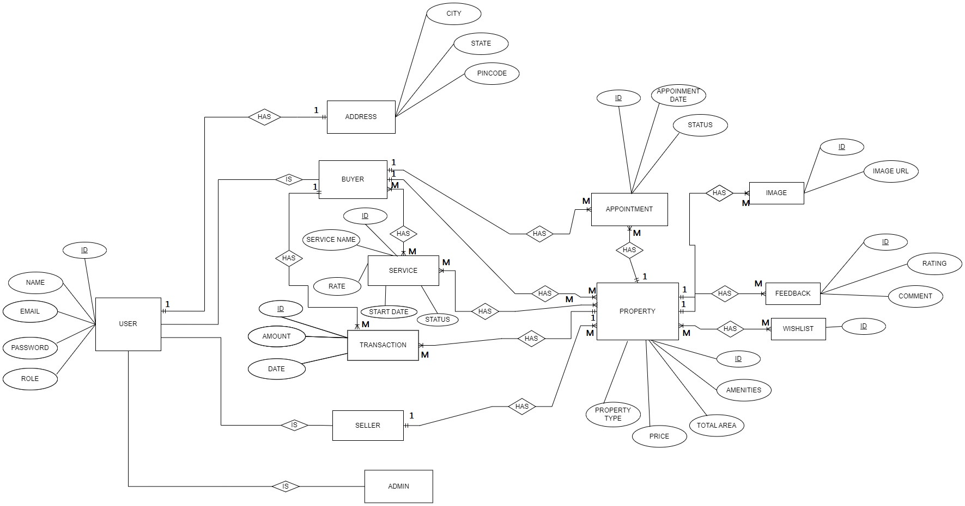

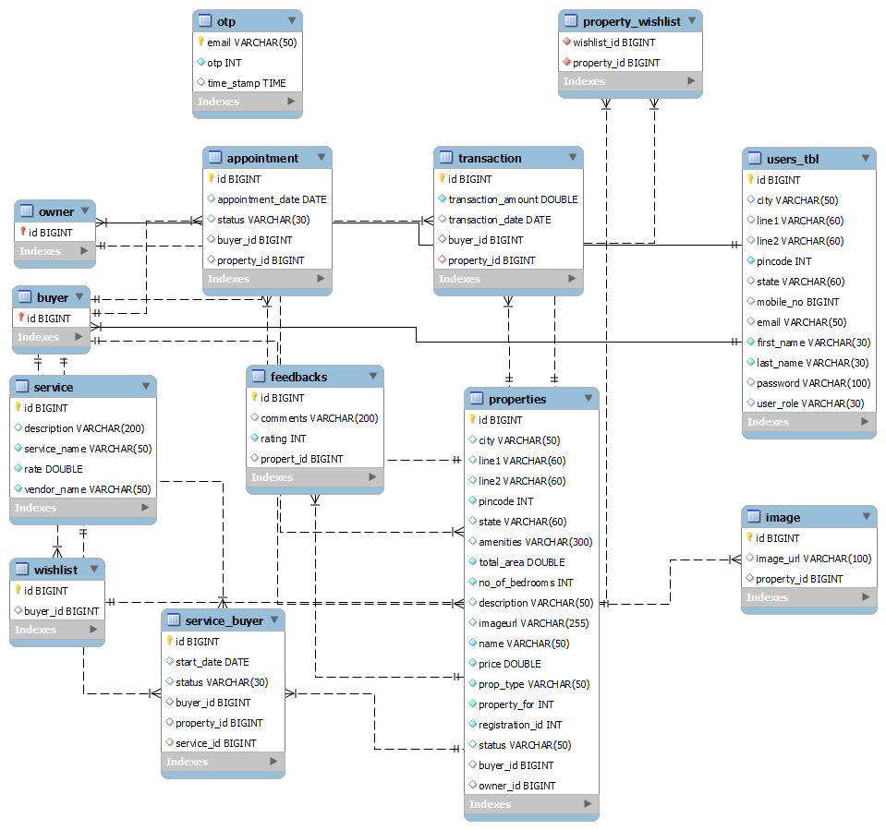**Entity Relationship Diagram**

**Class Diagram**

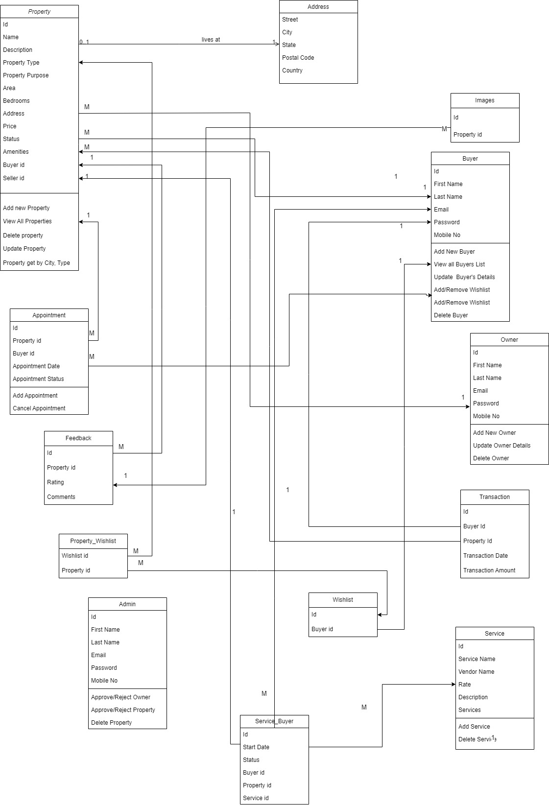

**Use Case Diagram**

Admin Use Case

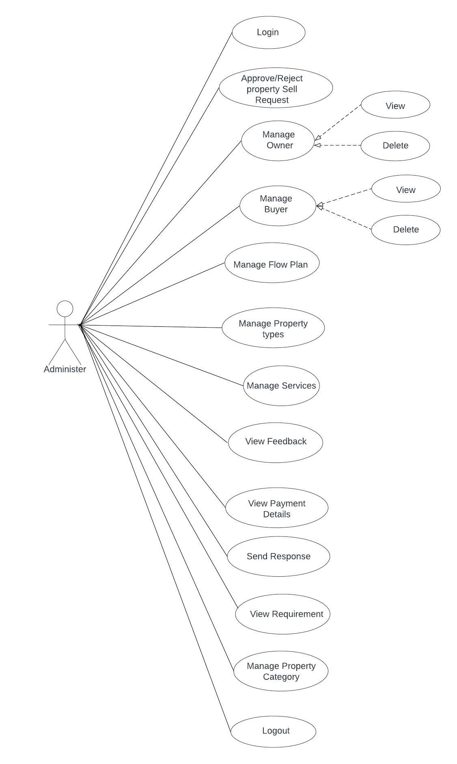

**Buyer Use Case Diagram**

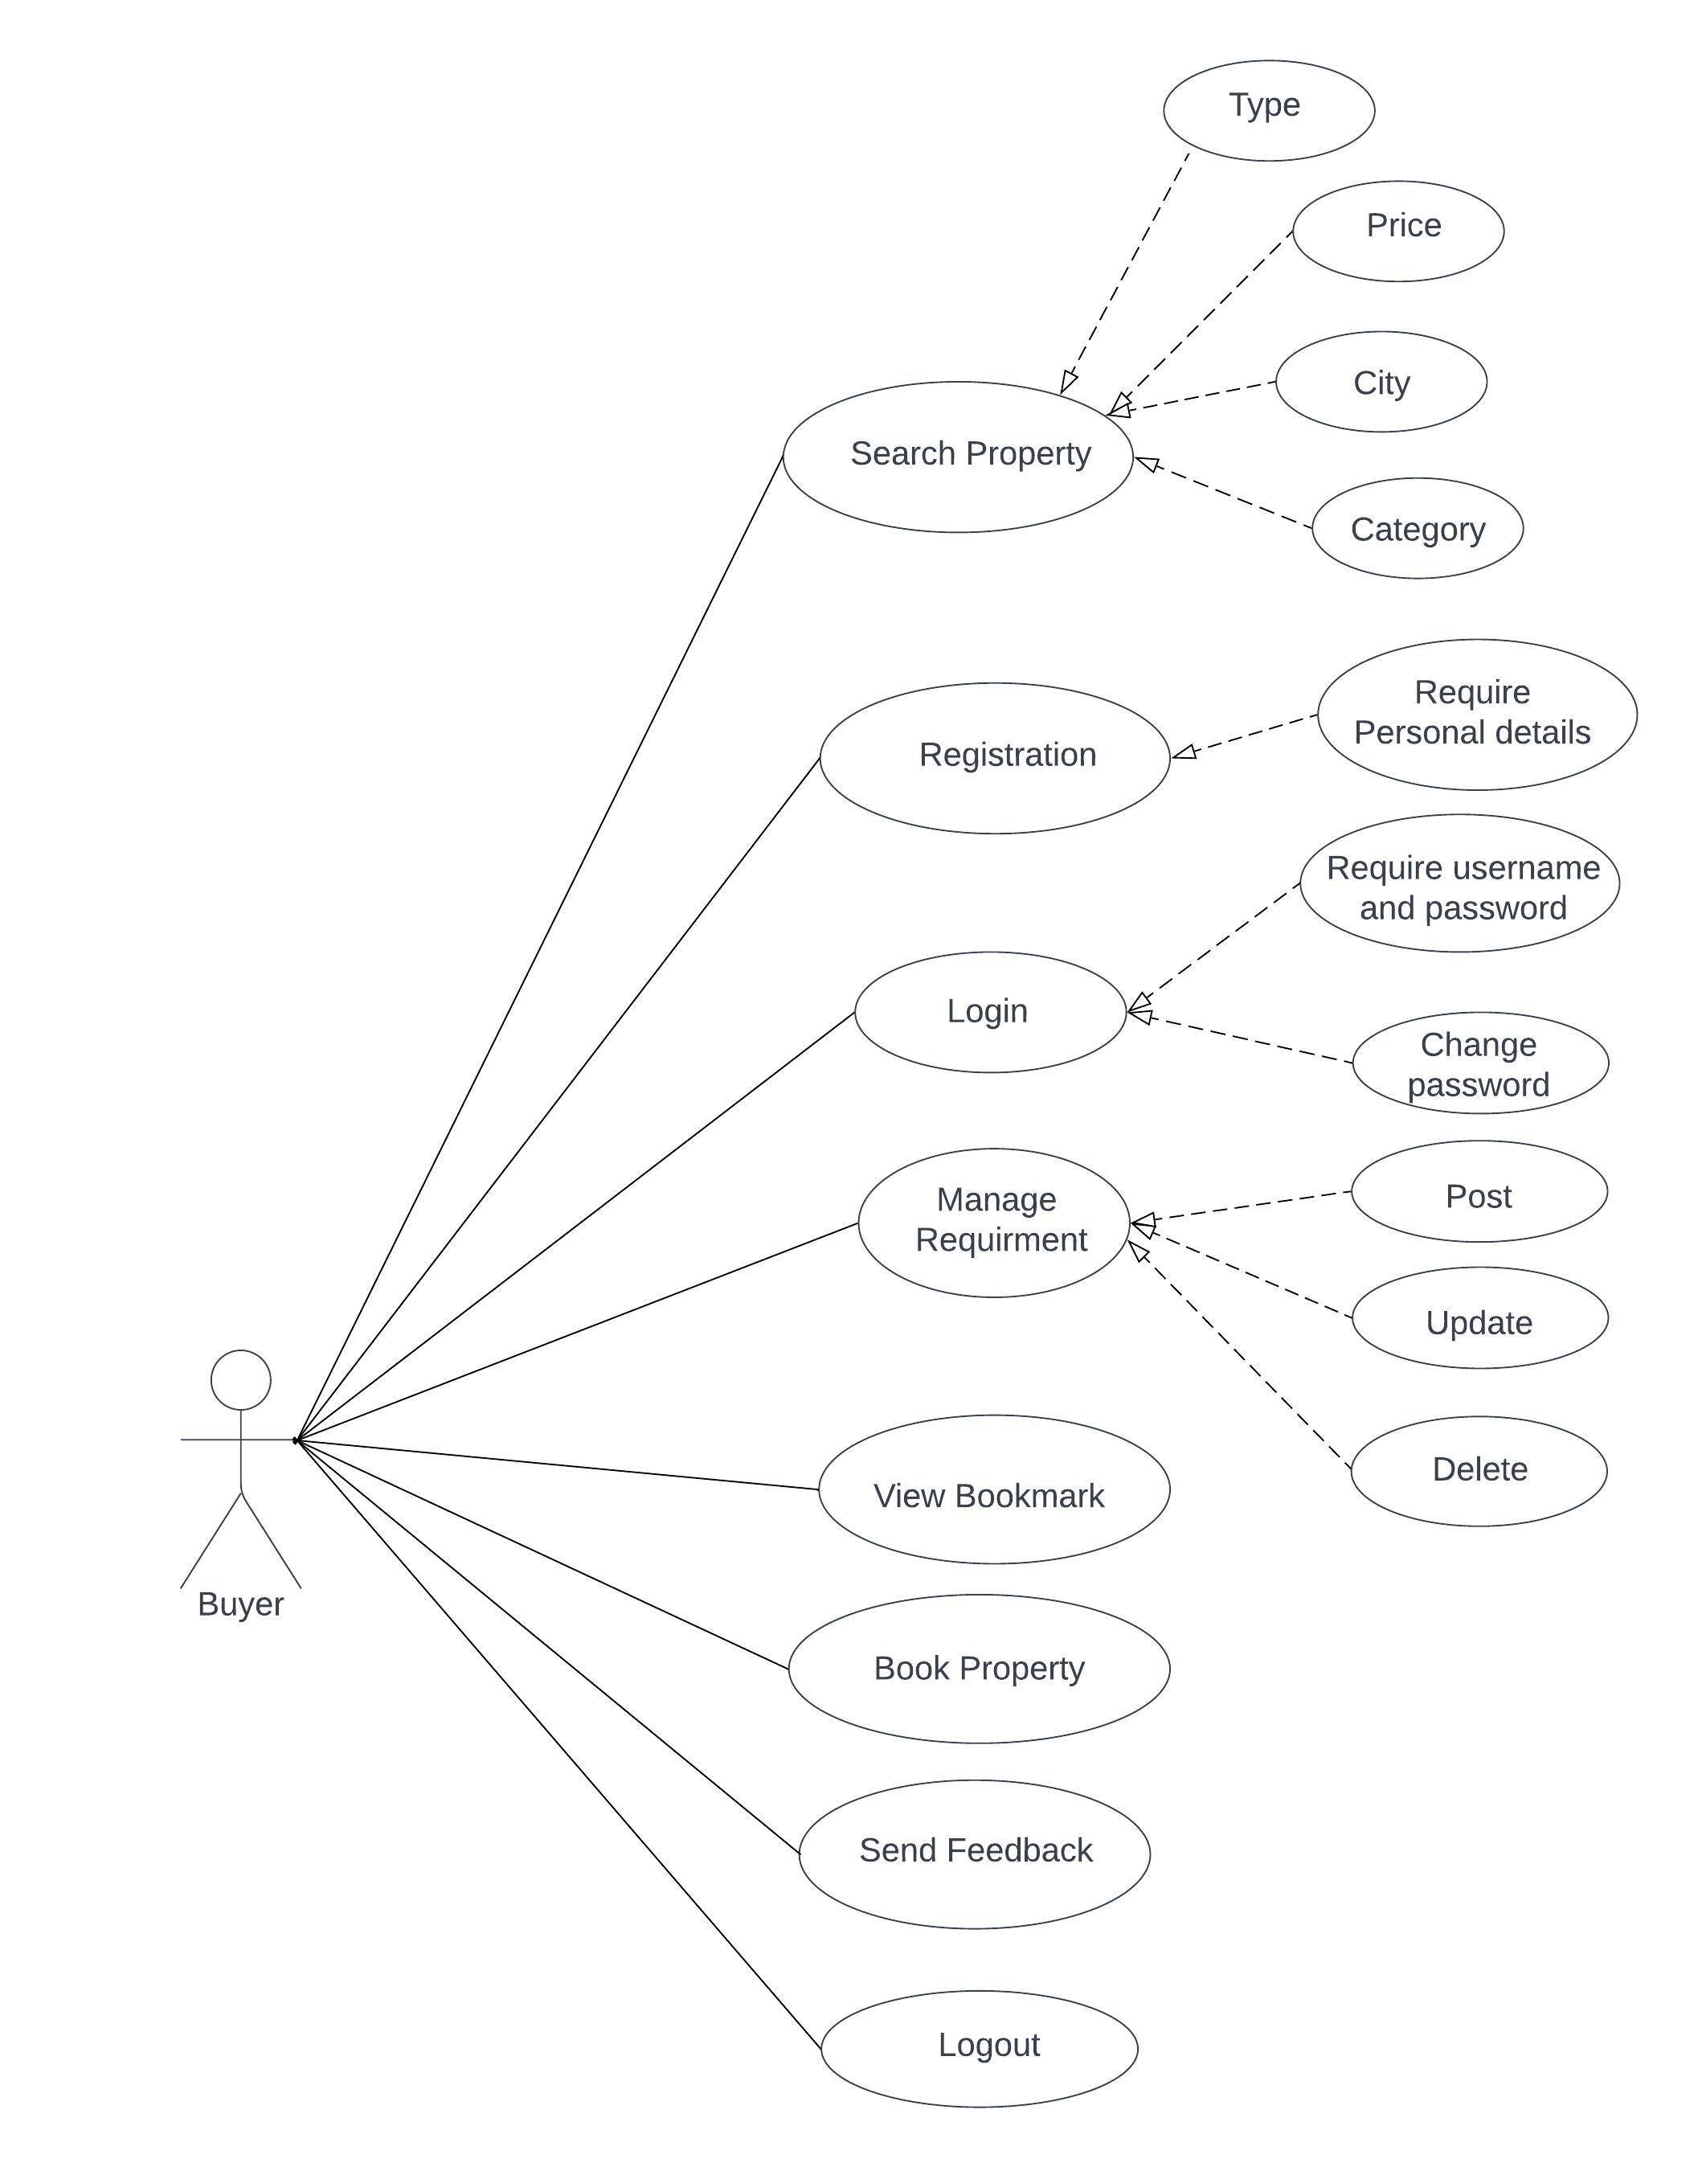

**Owner Use Case**

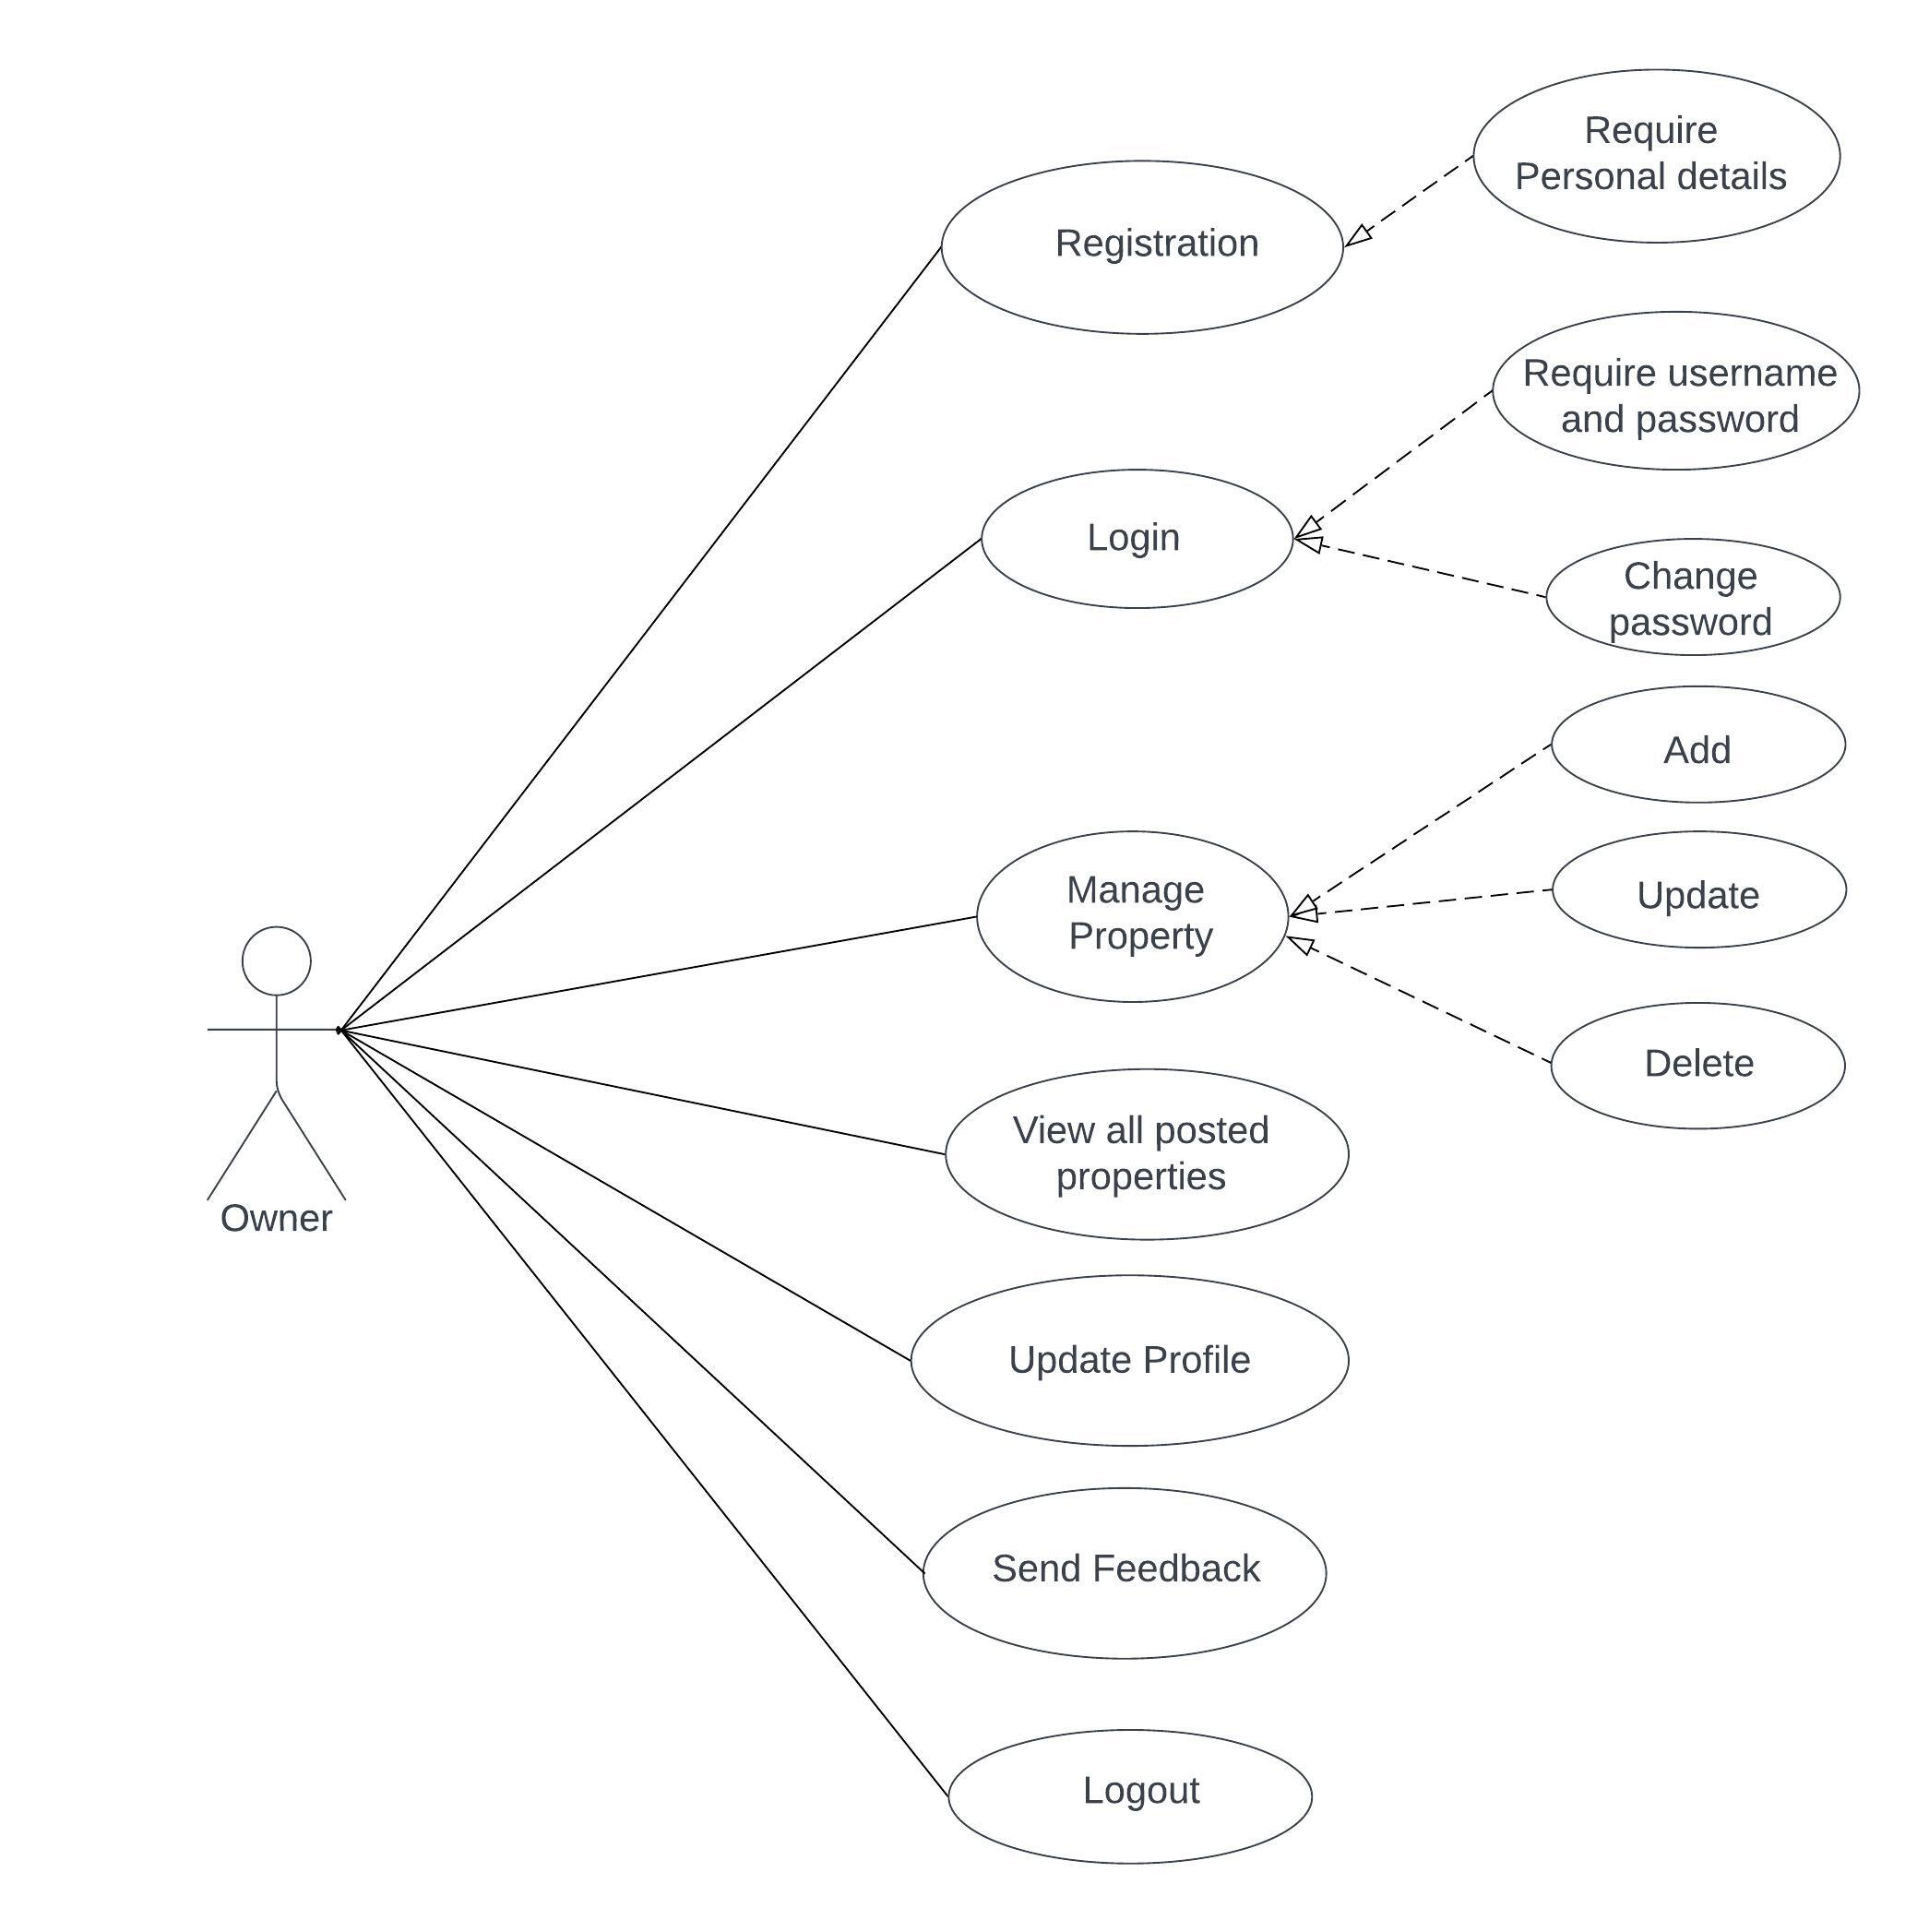

**Sequence Diagram**

**Login Sequence diagram**

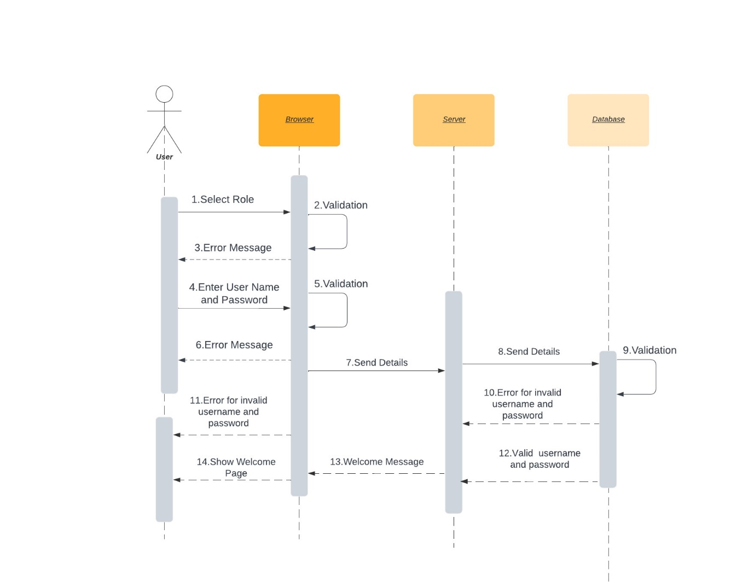

**RegisterationBuyerSeller**

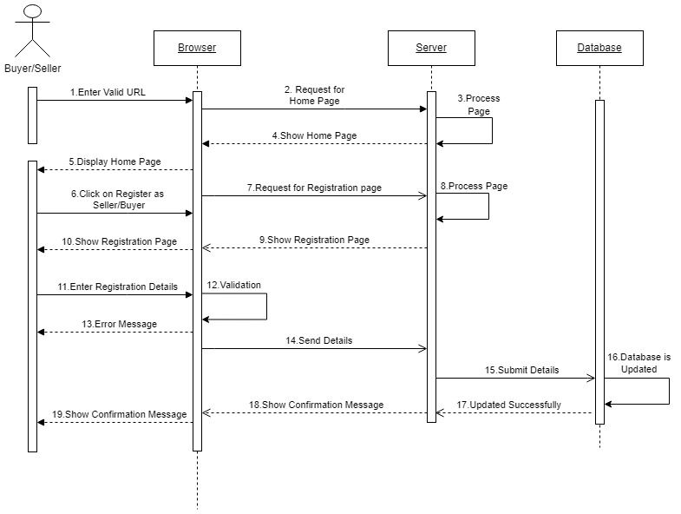

**Approve-Reject Admin Sequence diagram**

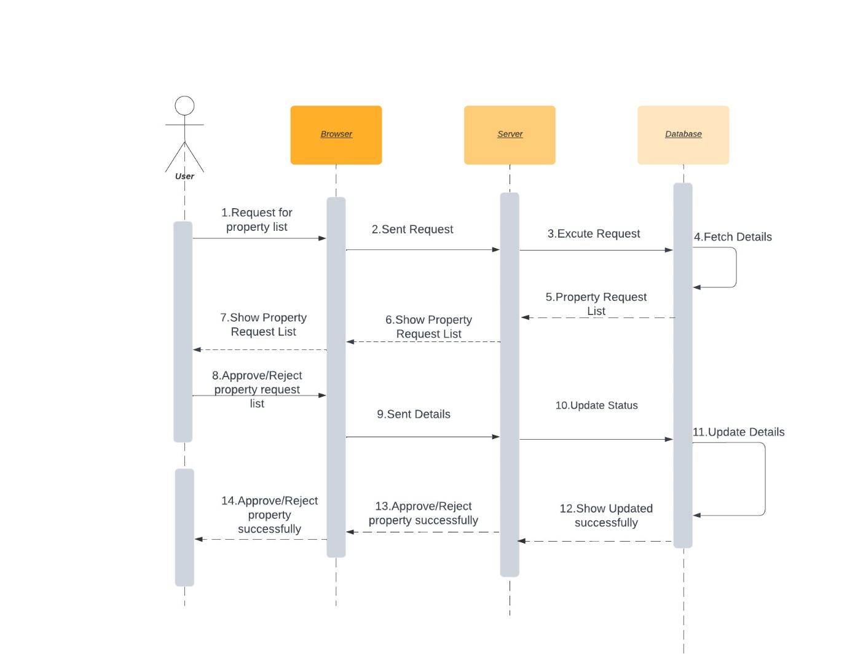

**Forgot Password**

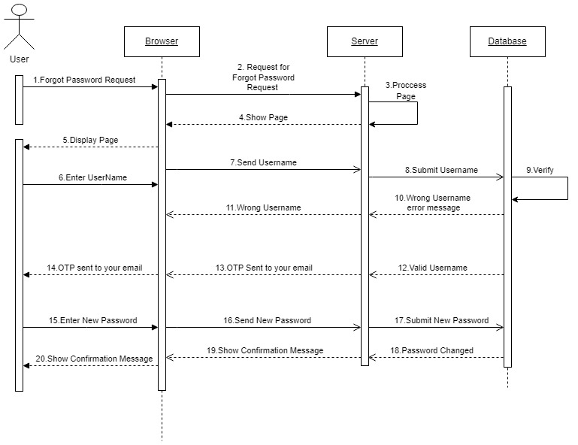

**6. Screen Shots**

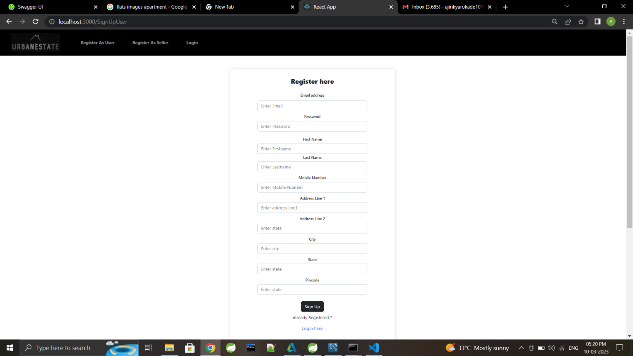**Signup/Register New User**

**Sign In**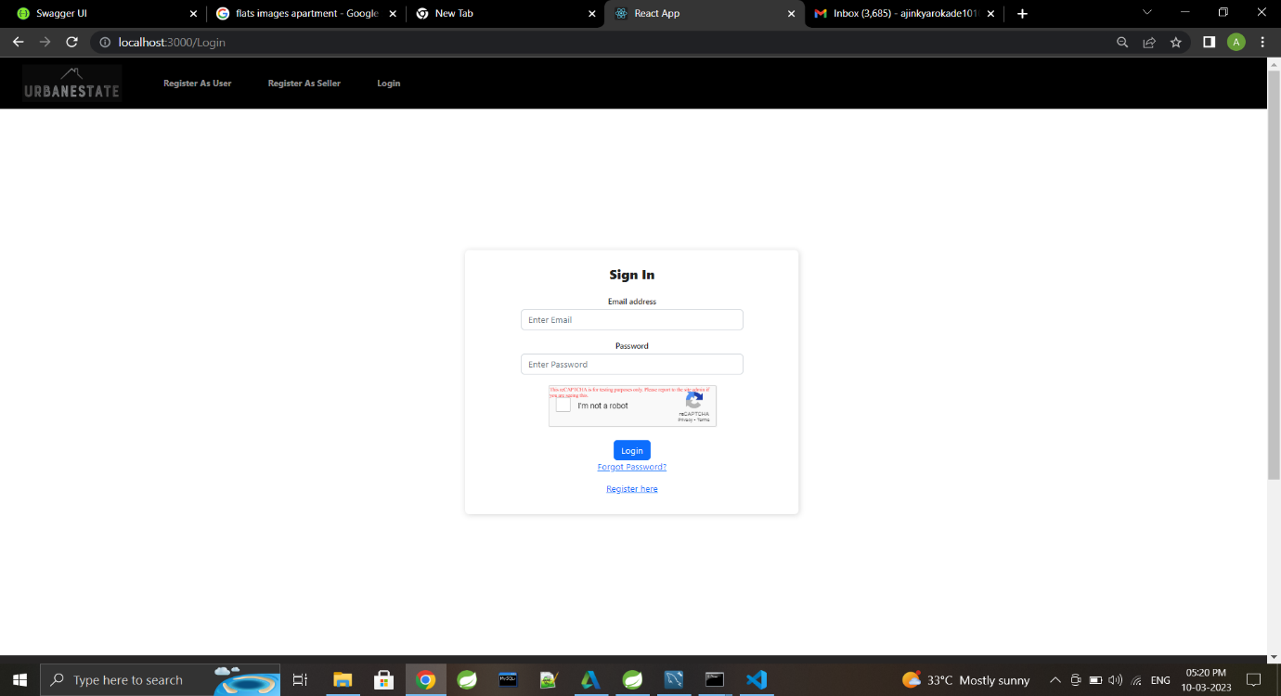

**Forgot Password**

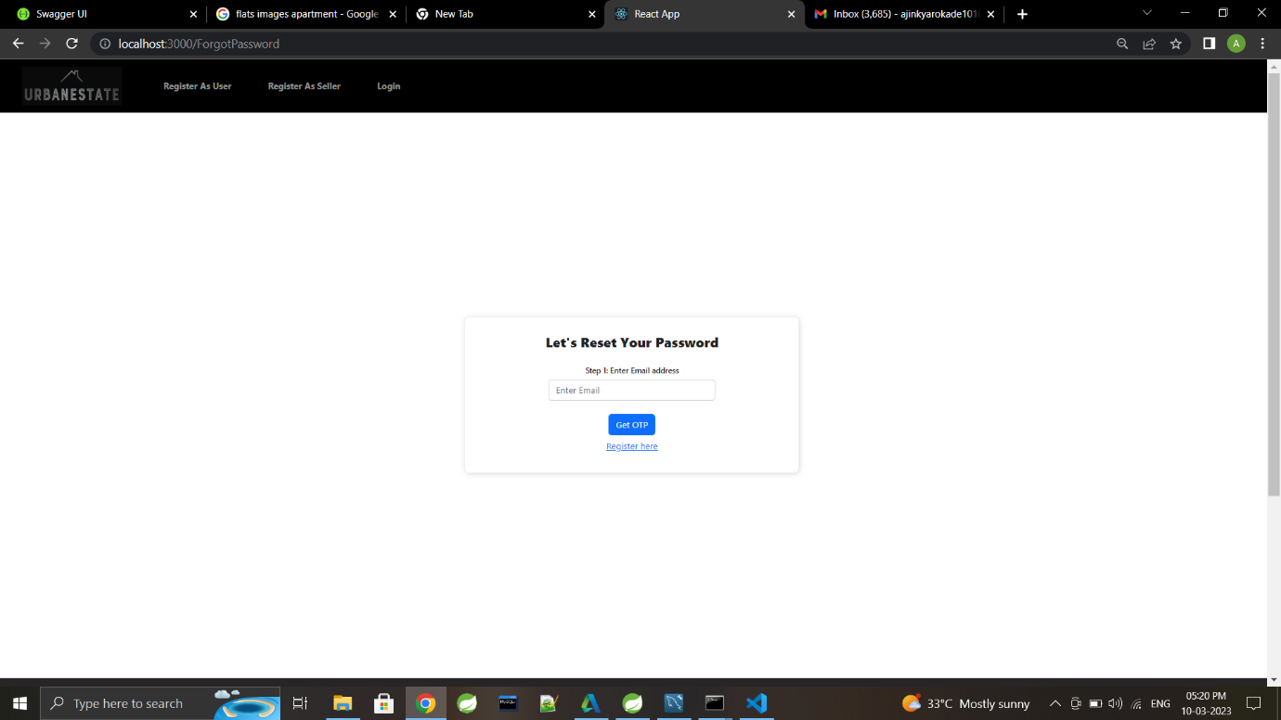

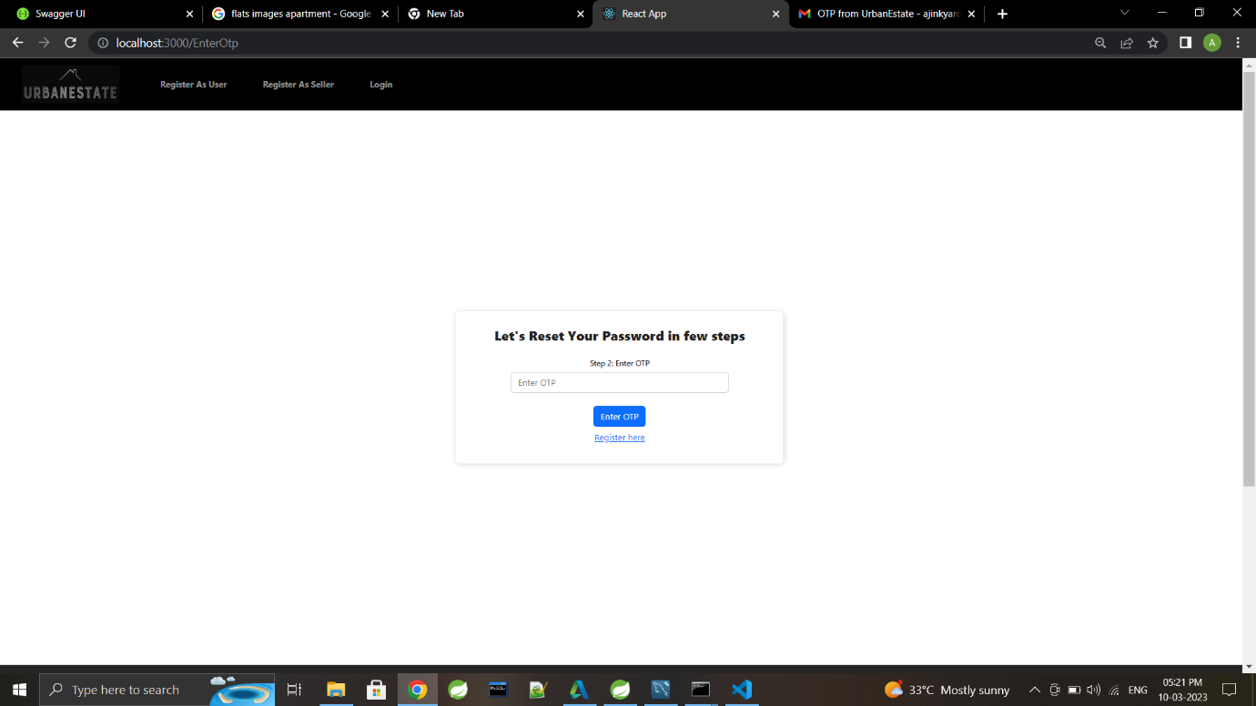

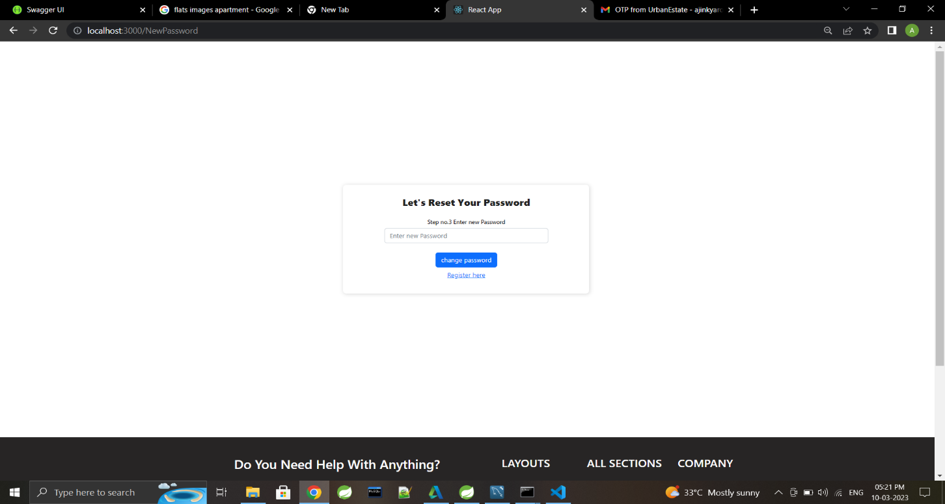

**Login Message**

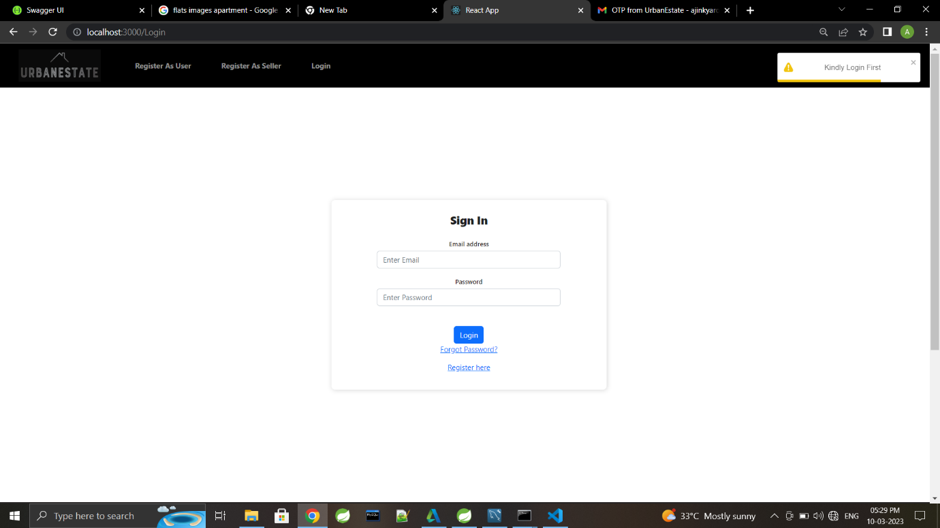

**Home Page After Login**

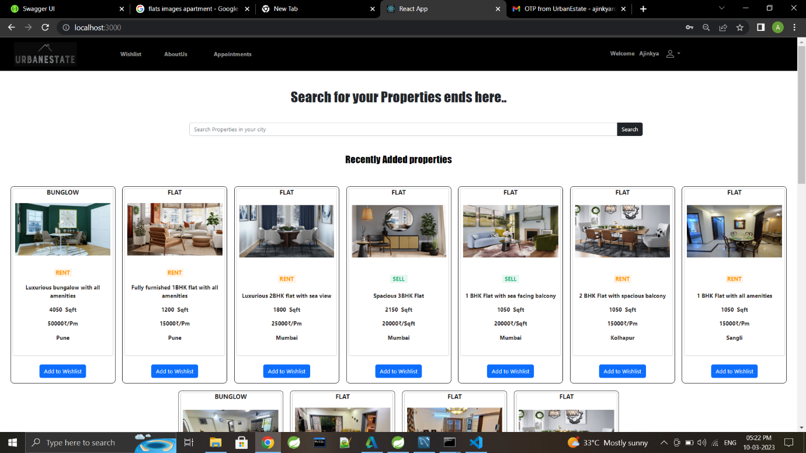

**Property Details**

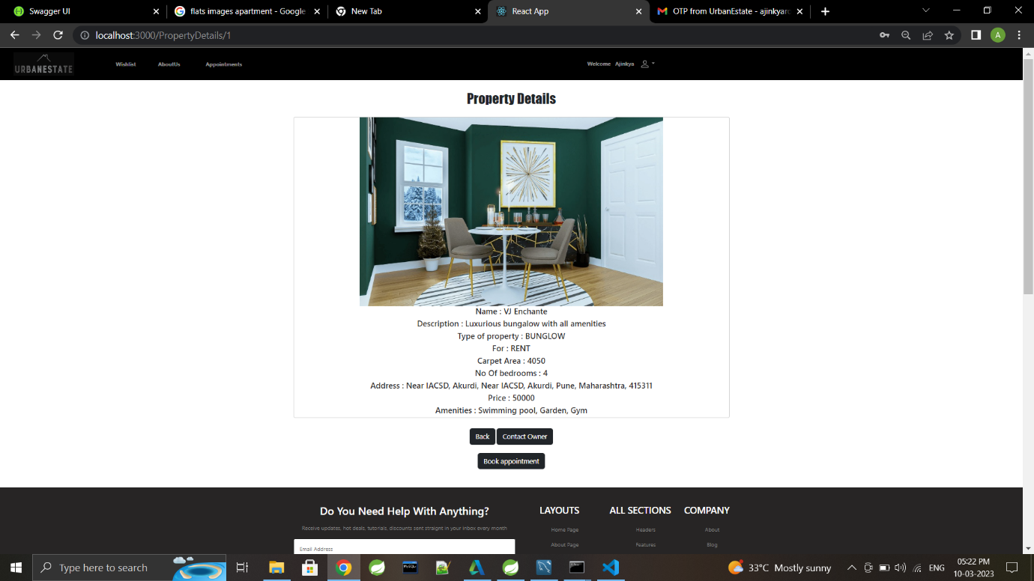

**Owner Details**

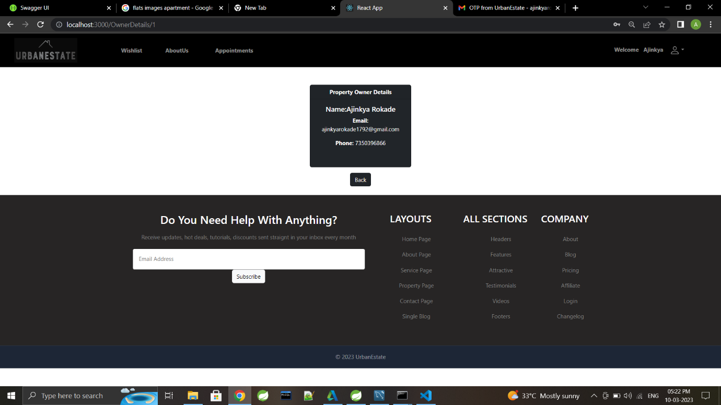

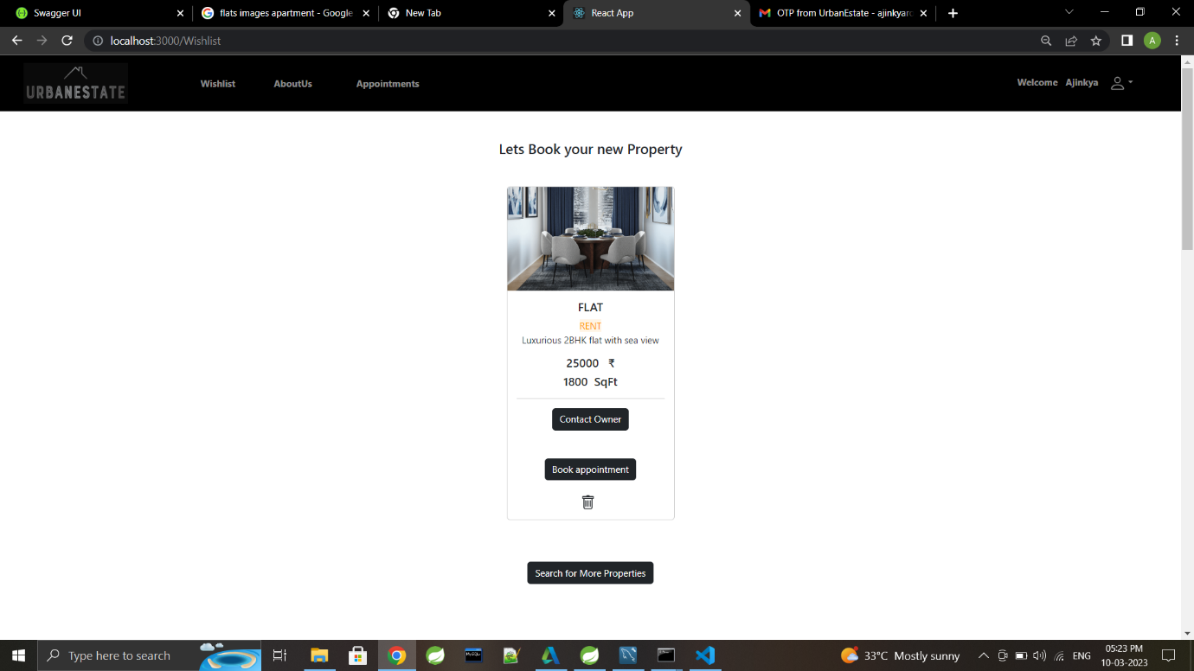

**Book Appointment On Particular Day**

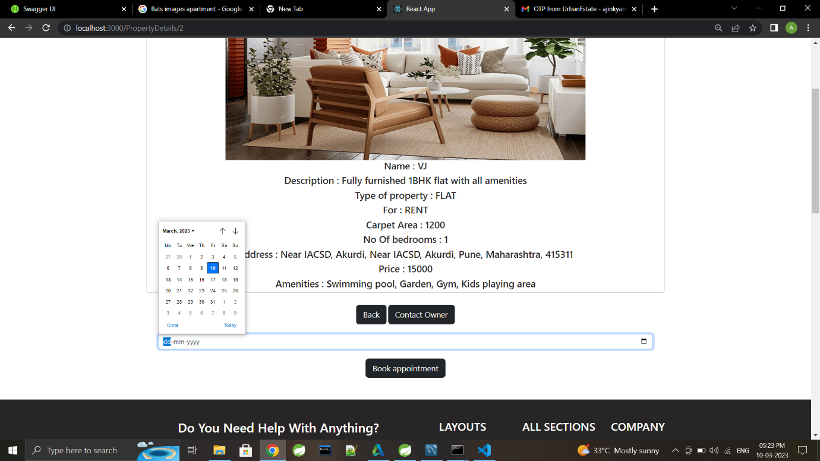

**Search Properties According to City**

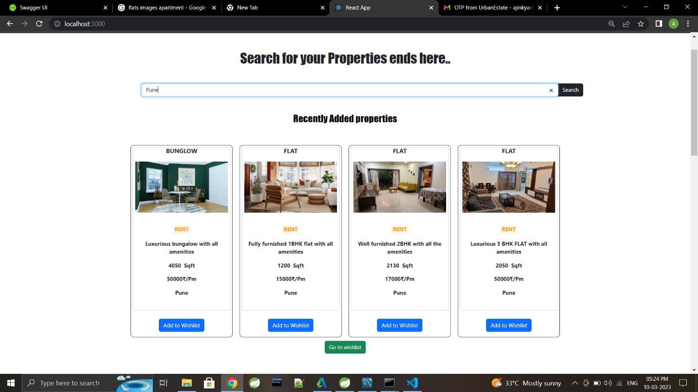

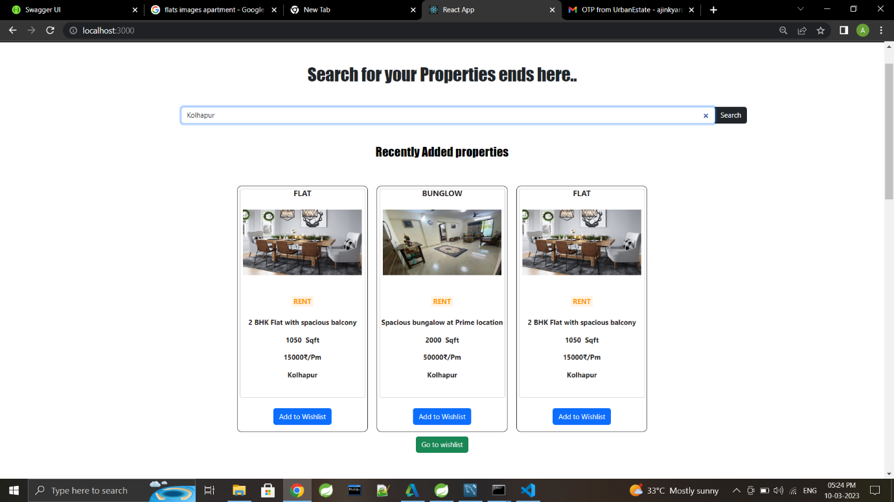

**Property Added to Wishlist**

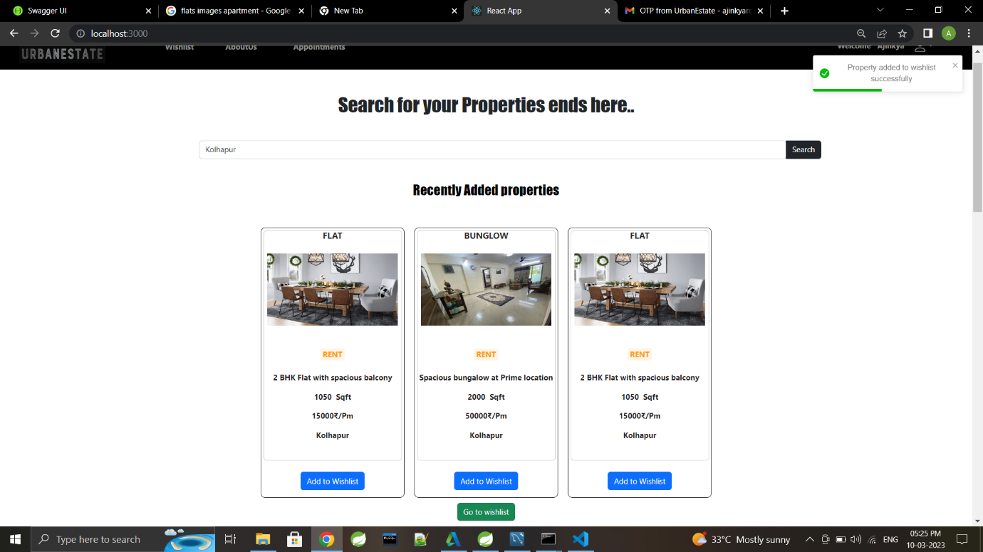

**From Wishlist book appointment**

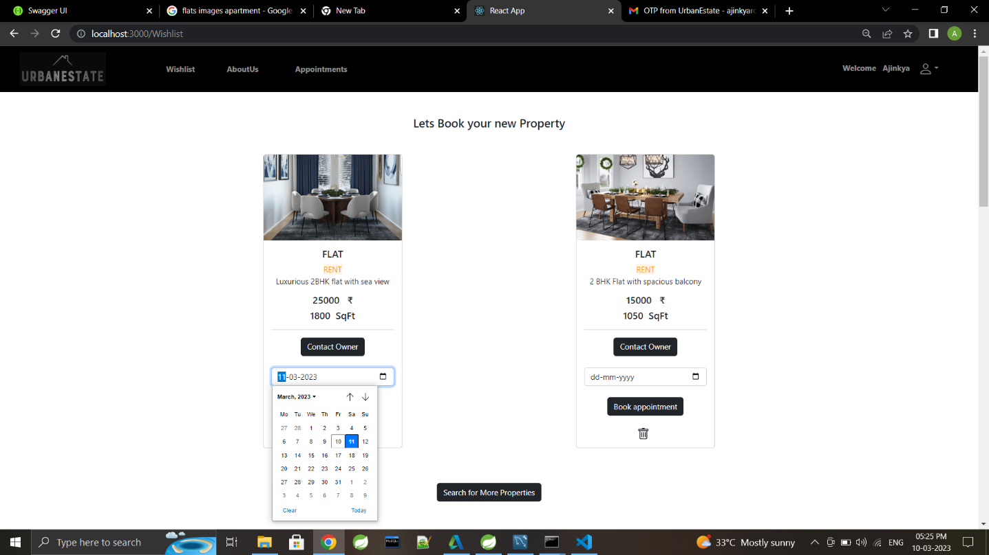

**Display as Appointment booked**

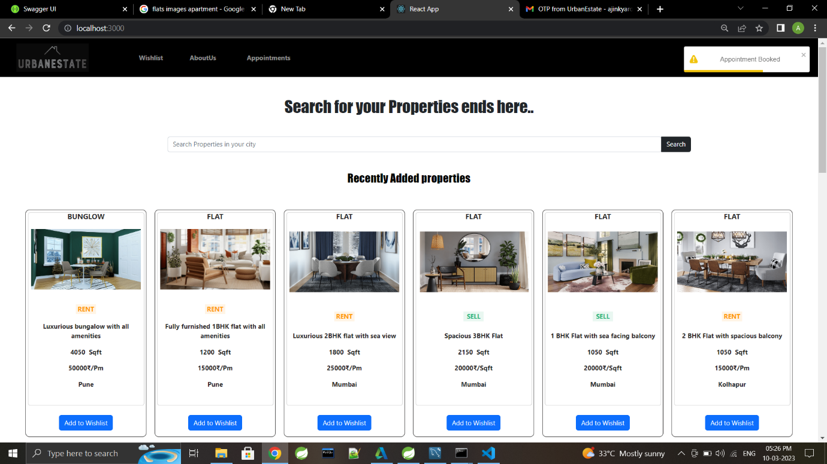

**About Urban Estate Page**

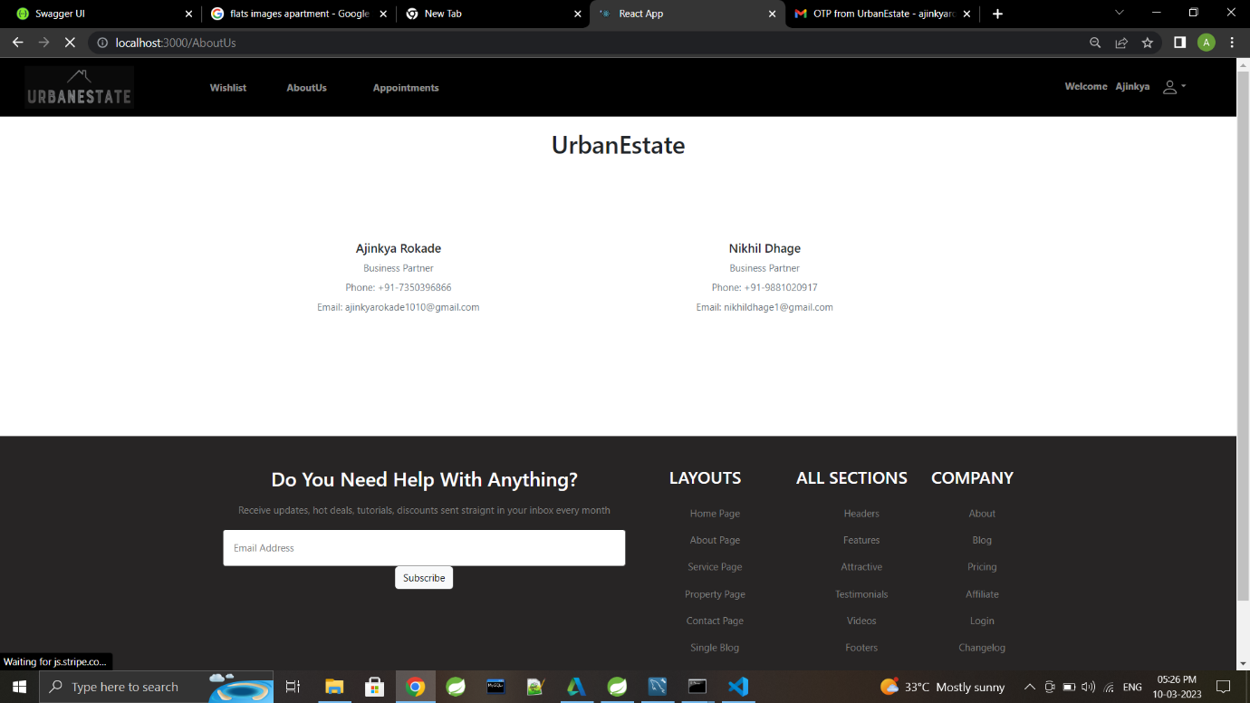

**For Update New Password**

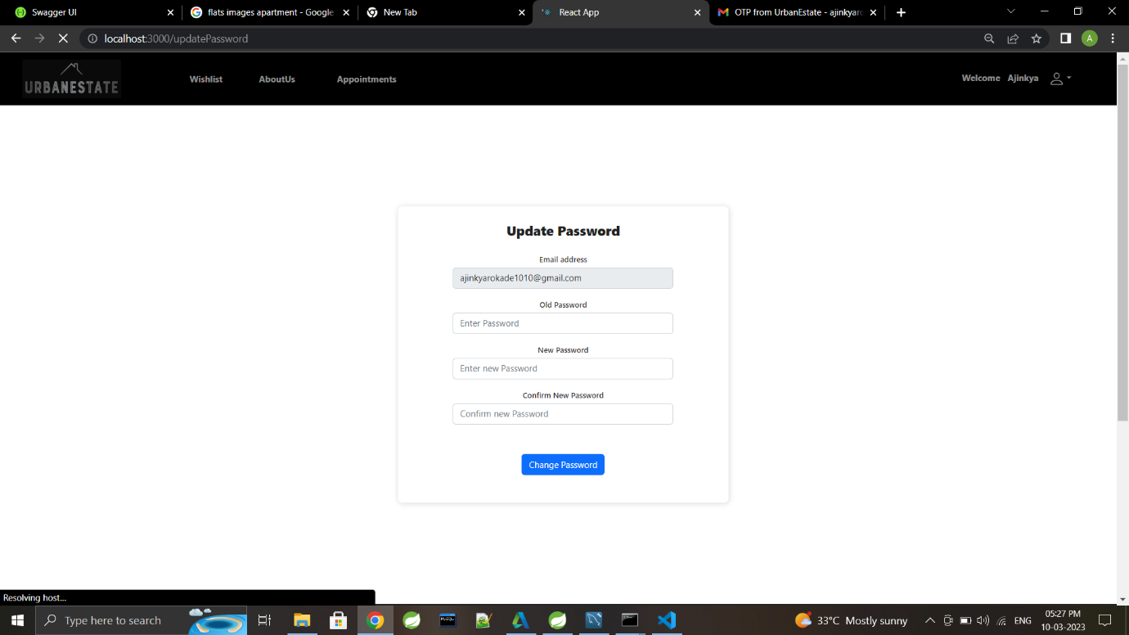

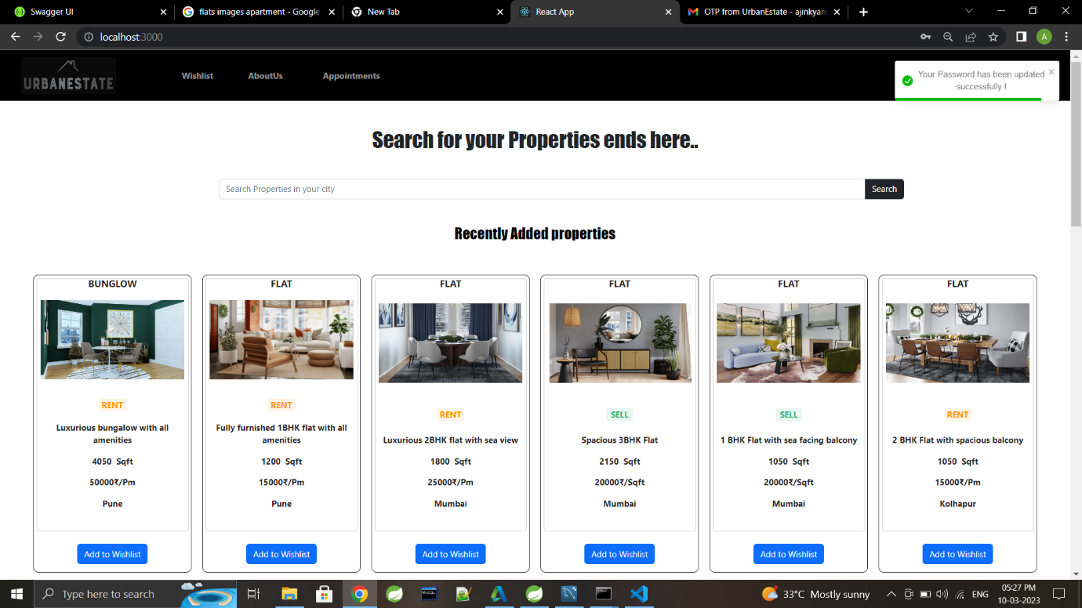

**Sign Out**

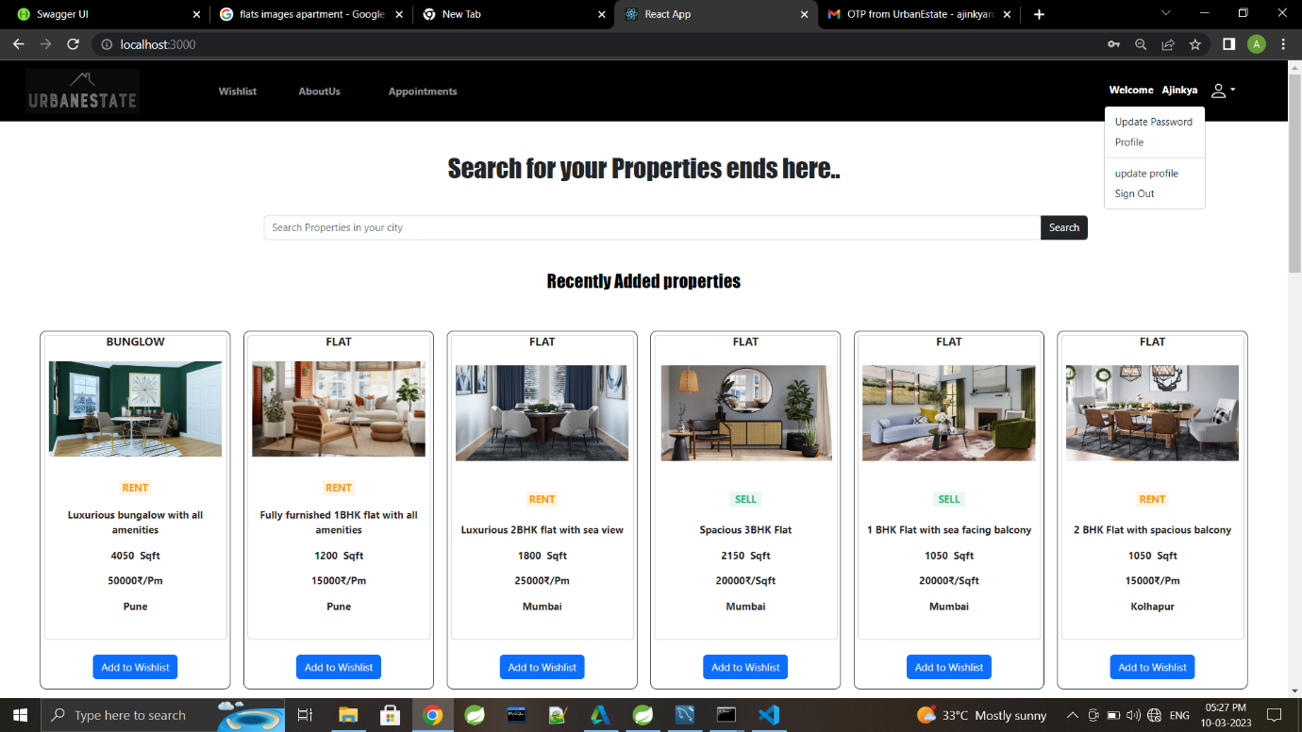

**Signing As Admin**

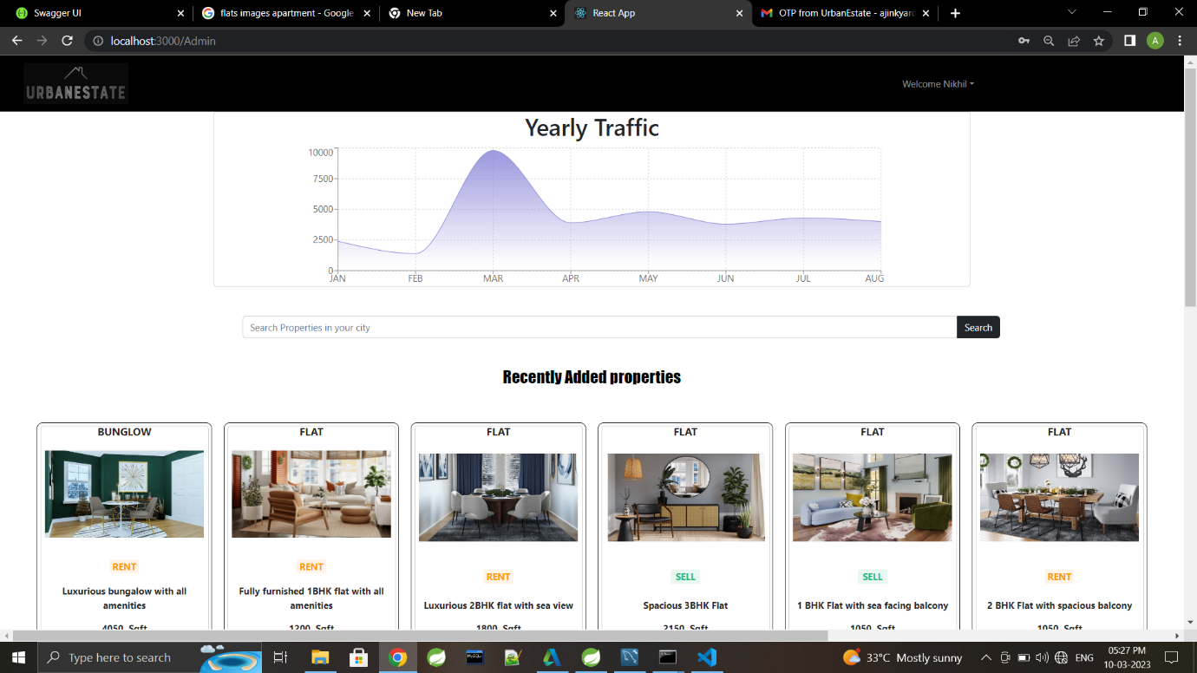

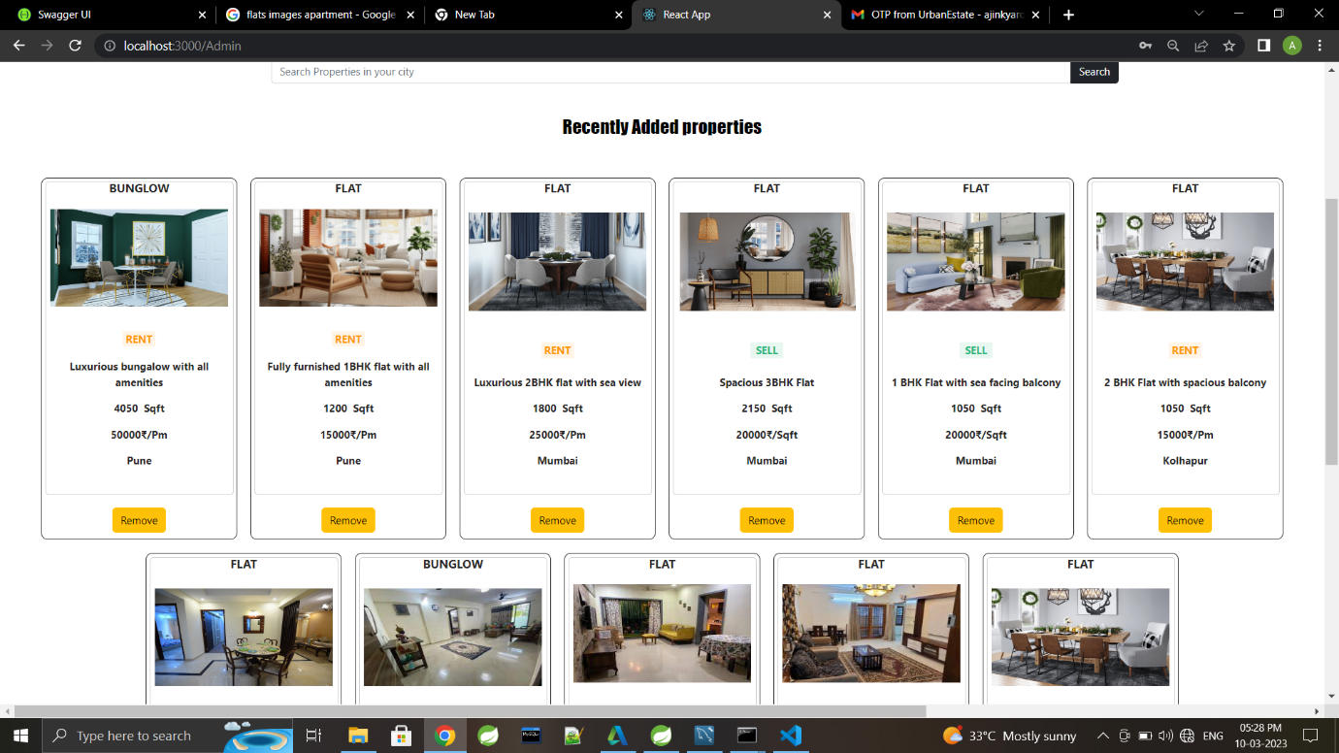

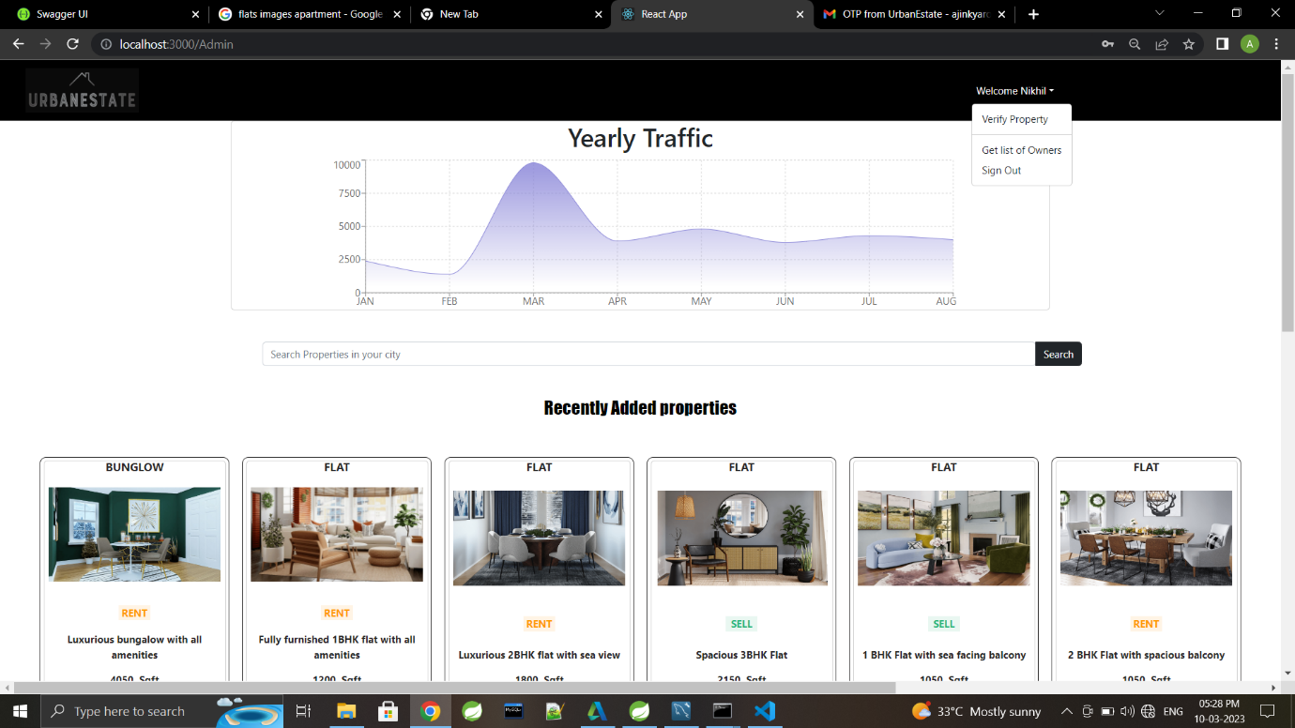

# **Software And Hardware Requirement**

**Server Side:**

**Processor:** Intel® Xeon® processor 3500 series

**HDD:** Minimum 500GB Disk Space

**RAM:** Minimum 4GB

**OS:** Windows 10, Linux 6

**Database:** MySQL

**Client Side (minimum requirement):**

**Processor:** Intel Dual Core

**HDD:** Minimum 80GB Disk Space

**RAM:** Minimum 2GB

**OS:** Windows 7, Linux

# **Future scope**

* This platform can be enhanced further by integrating payment gateway for customers In order to pay rent online
* Relevant services support like packing and moving, Pest control, Electrification and plumbing, Cleaning etc. could be added further.
* Customers will be able to make rental agreement on this platform which would include document verification.

# **conclusion**

* This platform includes designing and developing a digital platform that allows certified sellers to advertise their properties online and allows customers to visit the properties online with ocean of data regarding the property.
* This will aid customers with buying and renting legal properties verified with our legal team in accordance with rules and regulations everything online.

# **References**

* <http://www.google.com>
* <https://www.w3schools.com/>
* <https://docs.spring.io/spring-framework>
* <https://react-bootstrap.netlify.app/components/navbar>
* <https://stackoverflow.com>